**DSA LAB**

**NAME:ZAIN UL ABDIN**

**REG NO 096**

1. **In a large inventory of antique items, you are tasked with finding a specific vintage pocket**

**watch based on its serial number. You must implement a sequential search algorithm to**

**locate the watch within the collection of diverse antique items.**

**Source code:**

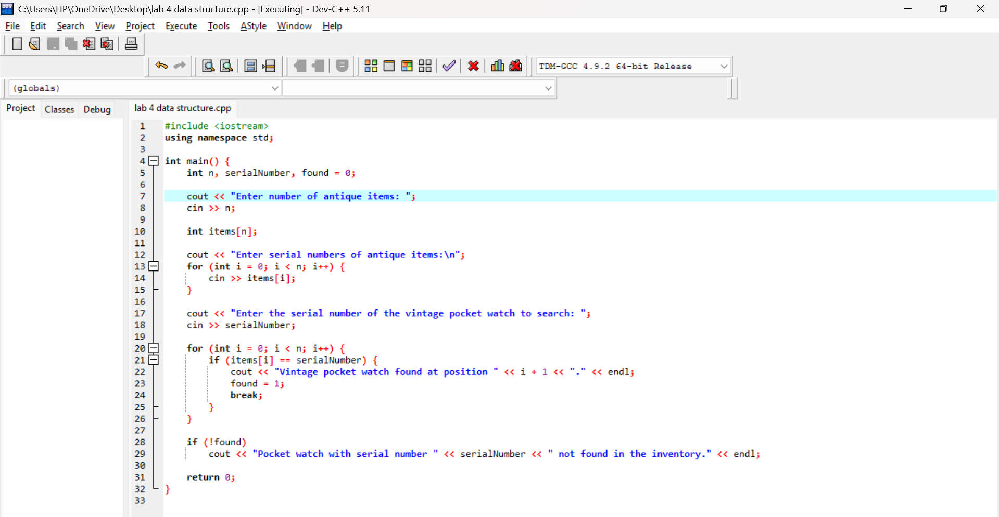

**Output:**

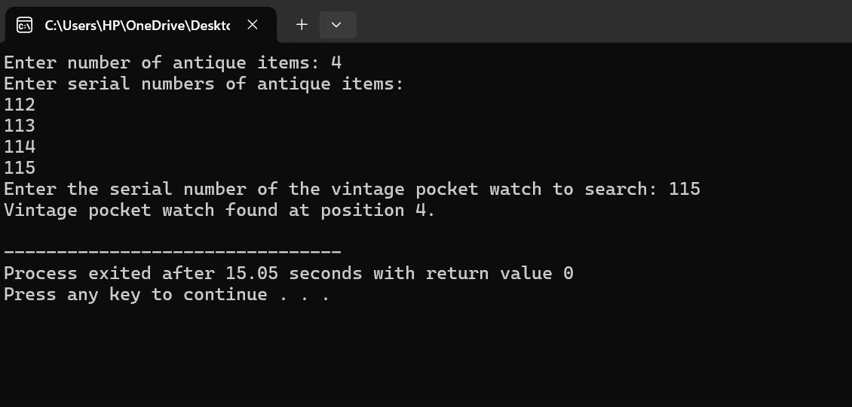

**2. In a sorted list of 10 student records by student ID, you need to find the details of a particular student efficiently. Implement a suitable search code to locate the student's ID using their unique identification number.**

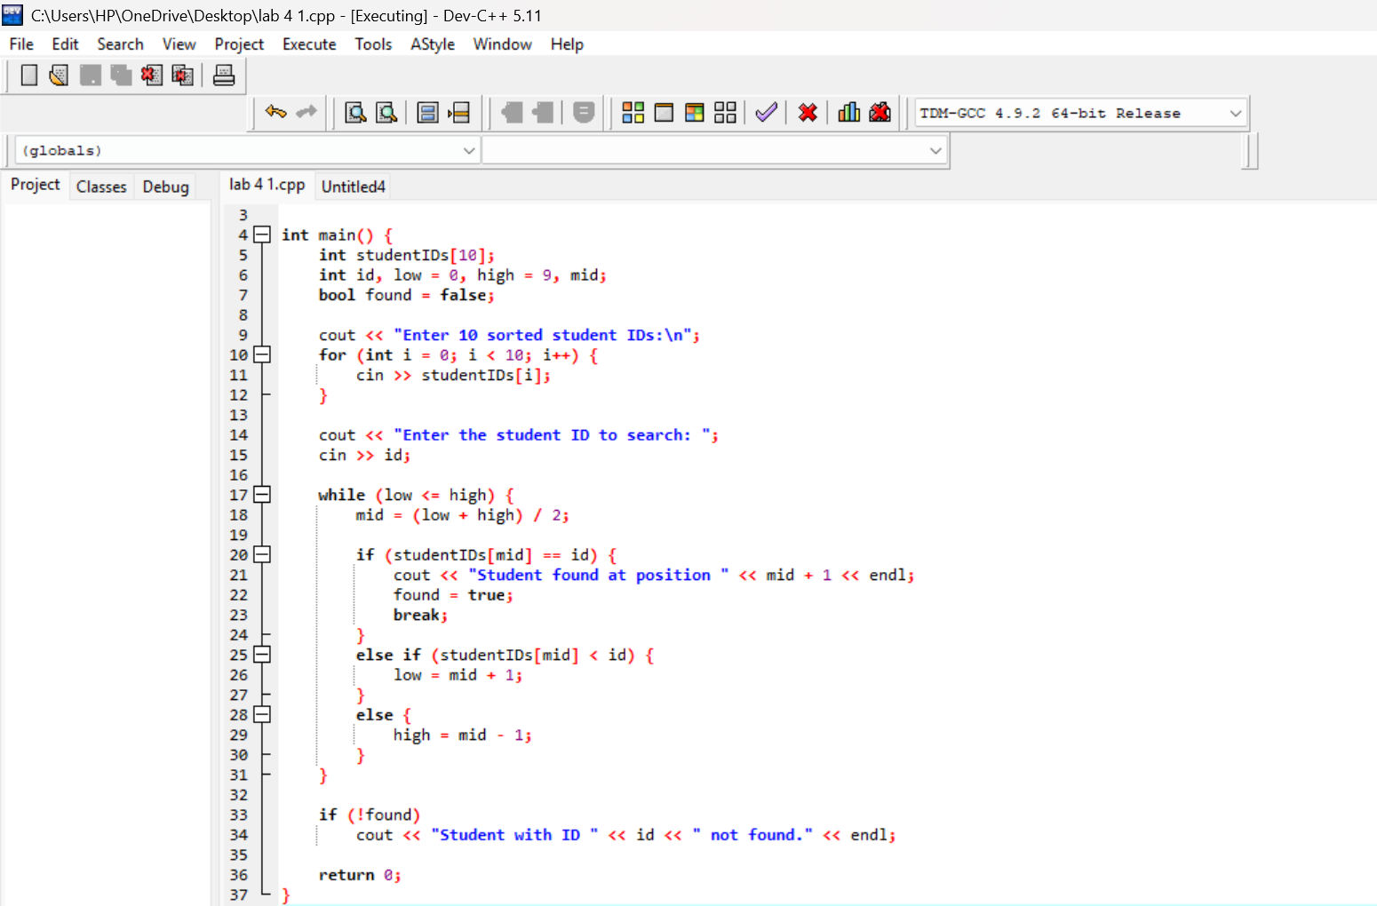

**Output:**

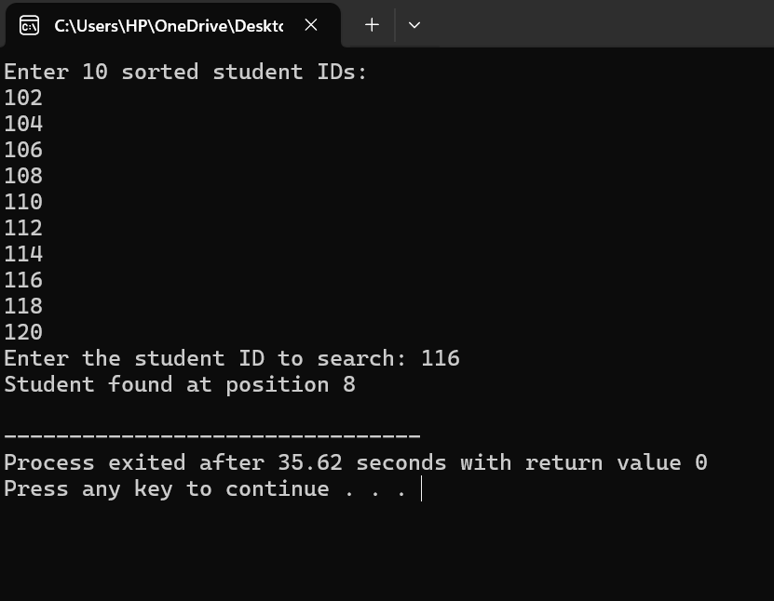

1. **In a classroom of 15 students, the teacher wants to organize the student's scores from the lowest to the highest. Implement a bubble sort algorithm to arrange the students' scores in ascending order, facilitating the ranking of their performance.**

**Source code:**

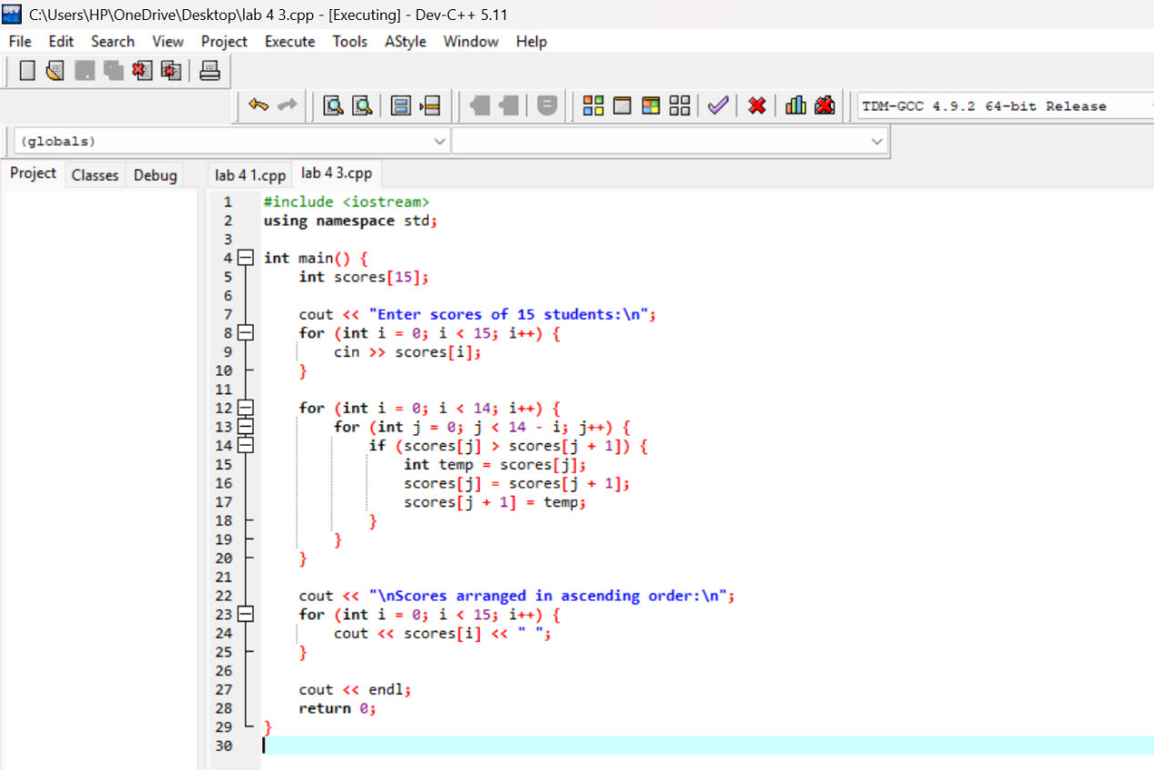

**Output:**

